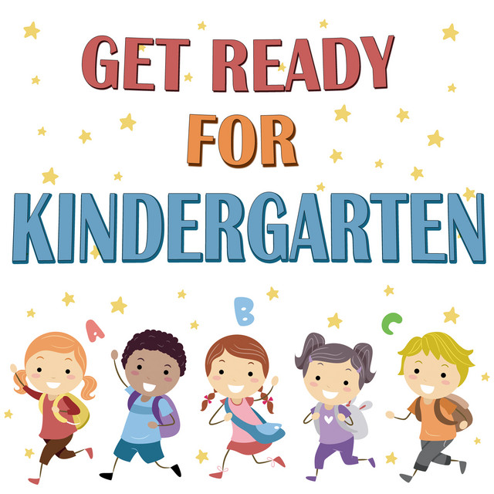

DATE: Thursday, May 26, 2022
TIME: 8:45 am – 10:00 am
PLACE: ESR Elementary Gym
WHO: Parent & New Kindergarten Student

